**CHAPTER III**

**PROBLEM ANALYSIS**

1. **Version of Linux Mint OS**

Linux Mint releases 2 times a year. Each Linux Mint release is given a version number and code name that uses the names of women and always end in "A" (example: Linux Mint 14 Nadia, 14 is the version number and Nadia is the code name ending in "a").

|  |  |  |
| --- | --- | --- |
| Version | Code Name | Release Date |
| 1.0 | Ada | 2006-08-27 |
| 2.0 | Barbara | 2006-11-13 |
| 2.1 | Bea | 2006-12-20 |
| 2.2 | Bianca | 2007-02-20 |
| 3.0 | Cassandra | 2007-05-30 |
| 3.1 | Celena | 2007-09-24 |
| 4.0 | Daryna | 2007-10-15 |
| 5 | Elyssa | 2008-06-08 |
| 6 | Felicia | 2008-12-15 |
| 7 | Gloria | 2009-05-26 |
| 8 | Helena | 2009-11-29 |
| 9 | Isadora | 2010-05-18 |
| 10 | Julia | 2010-11-12 |
| 11 | Katya | 2011-05-26 |
| 12 | Lisa | 2011-11-26 |
| 13 | Maya | 2012-05-23 |
| 14 | Nadia | 2012-11-20 |
| 15 | Olivia | 2013-05-29 |
| 16 | Petra | 2013-11-30 |
| 17 | Qiana | 2014-05-31 |
| 17.1 | Rebecca | 2014-11-29 |
| 17.2 | Rafaela | 2015-08-17 |
| 17.3 | Rosa | 2015-12-04 |
| 18 | Sarah | 2016-06-30 |

**Table 3.1 Version of Linux Mint OS**

1. **Advantages and Deficiency of Linux Mint OS**

**Advantages of Linux Mint OS:**

* Its use makes it easy for users because linux mint is a derivative of ubuntu so the tools are almost the same as ubuntu.
* The installation process is fairly easy.
* The space needed to install Linux Mint OS is not too large.
* Looks attractive and elegant.
* Is a Linux that is widely used by most people.
* It's integrated with Java Runtime.

**Deficiency of Linux Mint OS:**

* Linux Mint hardware resources are lacking.
* Stable release is out of date.

1. **Features of Linux Mint OS**
   * + 1. **Graphic**

* **Document Viewer**, This application is used to read documents (especially those that have a .pdf format).
* **GIMP Image Editor**, this application is used to process images (photos). This application can be said as Photoshop Linux.
* **gThumb**, this application is used to view and organize the images and photos we have.
* **Image Viewer**, used to browse and rotate images (photos)
* **Libre Office Draw**, part of Libre Office, this application is used to process and edit draws (designs), flowcharts, and logos. Its function is almost the same as CorelDraw on Windows (although in a simple form
* **Simple Scan**, used to scan documents.
  + - 1. **Internet**

The applications contained there in are:

* **Desktop Sharing**, this application is used so that other people (other users) can see the desktop that we have.
* **Firefox Web Browser**, one of the browsers that many people use to explore cyberspace.
* **Pidgin Internet Messenger**, an application to chat
* **Sun Java 6 Web Start**, an application for running Java.
* **Thunderbird Mail**, an application for sending and receiving e-mail using Thunderbird (Mail client).
* **Transmission**, used to download (share) and share (share) files.
* **XChat IRC**, used to chat with other people using Internet Relay Chat.
  + - 1. **Office**

This section can be said to be Microsoft's Linux Office

* **LibreOffice Base**, used to process data bases.
* **LibreOffice Calc**, used to process data in the form of numerical operations (such as Excel in Microsoft Office).
* **LibreOffice Draw**, used to design, edit, create flowcharts, logos and others that use vectors (points and lines).
* **LibreOffice Impress**, used to make presentations (such as Powerpoint in Microsoft Office).
* **LibreOffice Writer**, used to process data in the form of writing (such as Word in Microsoft Office).
  + - 1. **Sound & Video**

Applications included in this group is

* **Banshee**, an application for editing and organizing media collections both audio and video.
* **Brasero**, used for making and copying CDs / DVDs (like Nero on Windows).
* **GNOME MPlayer**, an application for playing audio and video media. This application can be used to rip off almost all existing media formats.
* **Movie Player**, as the name suggests this application is used to play movies and videos, almost all video formats are known to be able to use this application.
* **Sound Recorder**, used to record what we say.
* **VLC Media Player**, can be used to play almost all media both audio and video.
* **Volume Control**, used to adjust the volume.

1. **User Interface (UI) of Linux Mint OS**

Linux mint comes with a beautiful and easy to use interface. So it is suitable for beginners and for everyday computer use. Thus besides Ubuntu, Linux Mint is a very appropriate alternative to replace your Windows operating system.

Although from Ubuntu, Linux mint has its own interface package, Cinnamon and Mate.

1. **Cinnamon**

Cinnamon is a desktop that is very beautiful and elegant, and is perfect for those of you who like fancy desktops. With a luxurious look, of course Linux Mint Cinnamon will be very good if your computer hardware specifications are fairly mode.

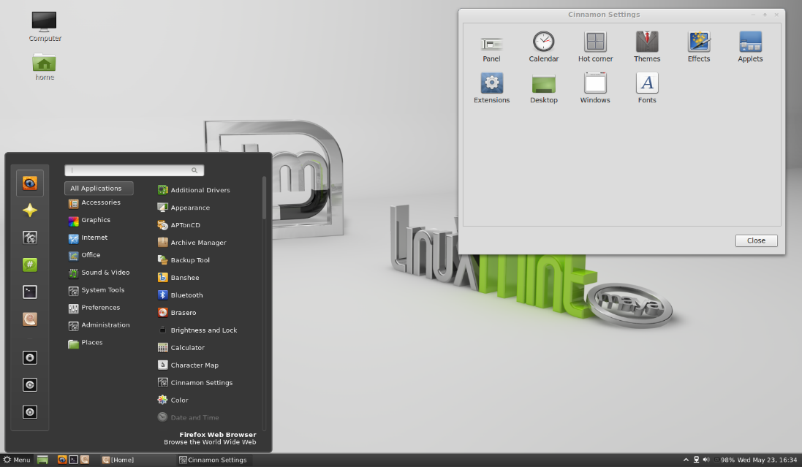

**Figure 3.1 User Interface of Cinnamon Linux Mint OS**

1. **Mate**

Mate, is a simple and lightweight desktop developed from GNOME 2. Mate can be enhanced with luxurious effects by installing CCSM applications. Mate works well in modern and old hardware specifications.

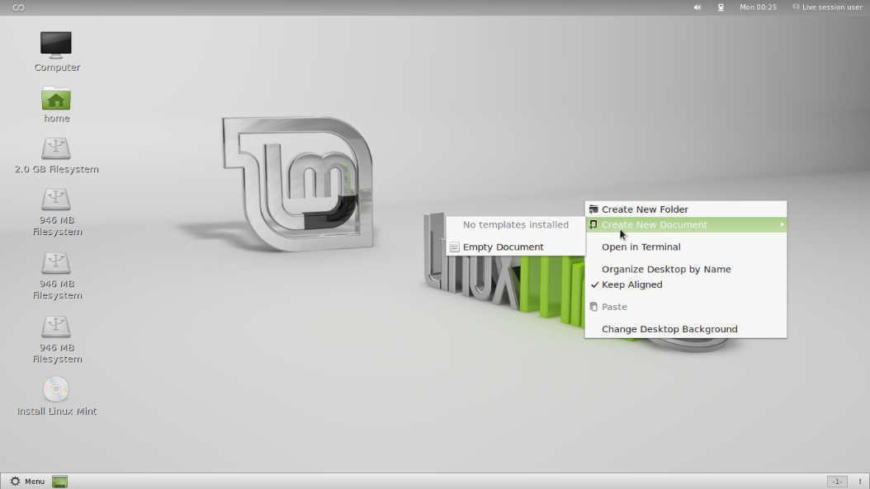

**Figure 3.2 User Interface of Mate Linux Mint OS**

In addition to using the Cinnamon and Mate desktop, Linux Mint also offers KDE and XFCE desktops. So that with the presence of a varied desktop will give you a freedom to choose Linux Mint in accordance with the hardware specifications you have.

1. **XFCE**

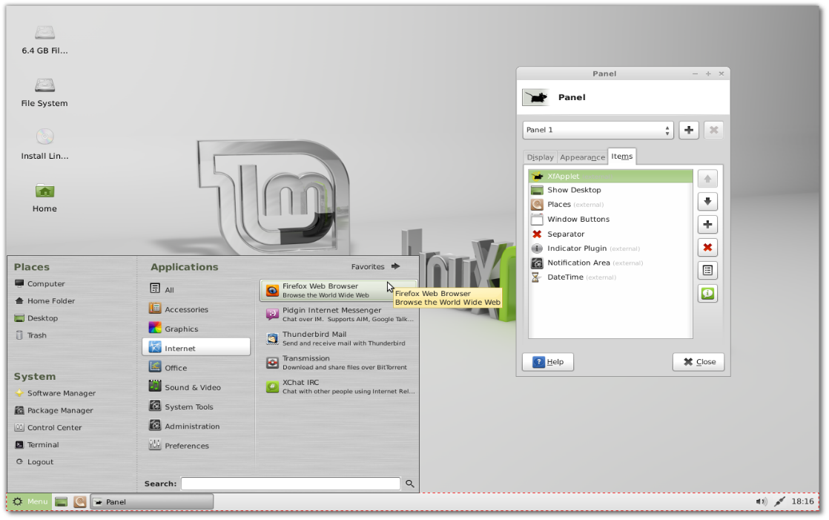

**Figure 3.3 User Interface of XFCE Linux Mint OS**

1. **KDE**

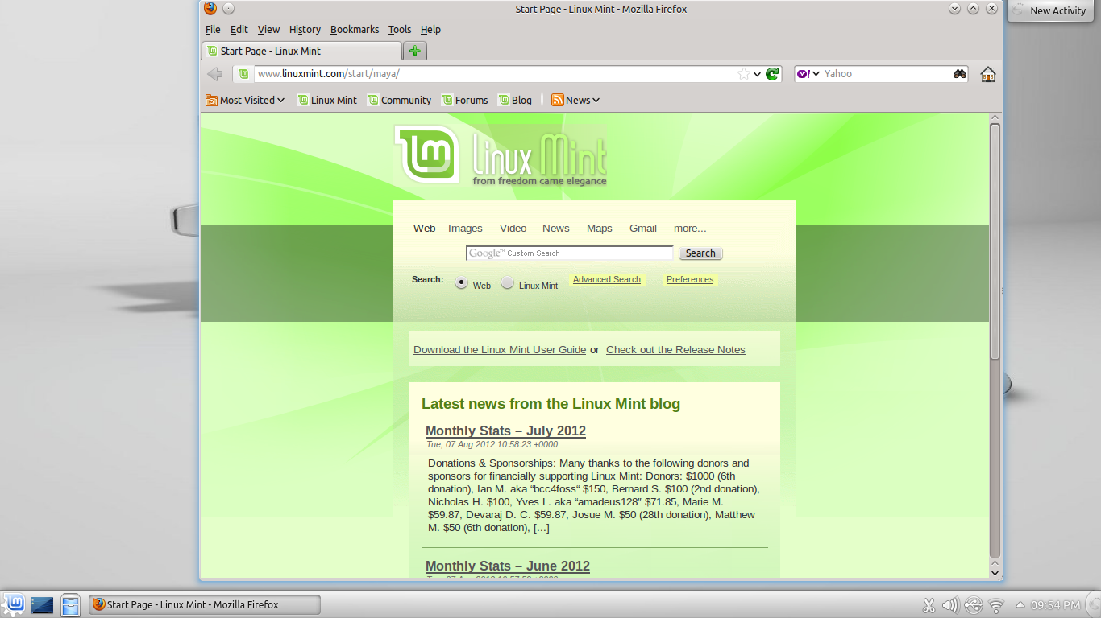

**Figure 3.4 User Interface of KDE Linux Mint OS**